SHIPPER’S INSTRUCTIONS TO ARRANGE FOR SHIPMENT OF GOODS
Exporter (Shipper)付貨人 |  |  |  |  | HONG |  |  |  |  |  |  | KONG
BR No. TELEPHONE |  |  |  |  |  |  |  |  |  |  |  | KONG
 |  |  |  |  | TRANSPORT GROUPAGE INTERNATIONAL (HK) LTD
Consignee (If “order” enter notify in space below) 收貨人
 |  |  |  |  | Room 7, 9/F., Wang Lung Industrial  Building, No.11 Lung Tak Street,  Tsuen Wan, N.T., Hong Kong. |  |  |  |  | Tel : (852) 2766 2651  2766 2993  Fax (852) 2766 2780
 |  |  |  |  | Airfreight Charges 運費 | ˇ/ × To be prepaid  預付 * |  |  |  | ˇ/ × To be collected  (if service available)  到付 *
TELEPHONE: |  |  |  |  | Other charges  其他費用 | ˇ/ × To be prepaid  預付 * |  |  |  | ˇ/ × To be collected  (if service available)  到付 *
Notify Party (Only if not stated above : otherwise leave blank ) 並通知 |  |  |  |  | Other charges  其他費用
Type of Service Required
ˇ/ ×IATA (Direct) ˇ/ × Consolidation ˇ/ ×Charter *
 |  |  |  |  | Export License No. 出口証號碼 |  |  |  | C.O No. 來源証號碼
TELEPHONE:
Carrier 航空公司名稱 |  | From (Airport of departure) 起運地 |  |  | Special Instructions: 附注
To (Airport of destination)目的地 |  | Airline counter signature 航空公司加簽  Yes/ NO *
Country of Origin  來源地 | Shipper’s C.O.D  代收金額 |  | Insurance Amount  保險金額 |  |  | Declared Value for Carriage  運輸金額 |  |  |  |  | Declared Value for Customs  報關金額
Marks and Nos.; No. and Kind of Packages ; Description of Goods 嘜頭, 貨品名稱及數量 |  |  |  |  |  | Gross Weight: 毛重 |  |  |  |  | Measurement: 呎碼
CARGO READY DATE:

Documents to accompany airwaybill or house airwaybill 附寄單據文件
Packing List 包箱表 ˇ/ ×; Commercial Invoice 發票ˇ/ ×; Certificate of Origin來源証 ˇ/ ×; Others 其他ˇ/ ×; *
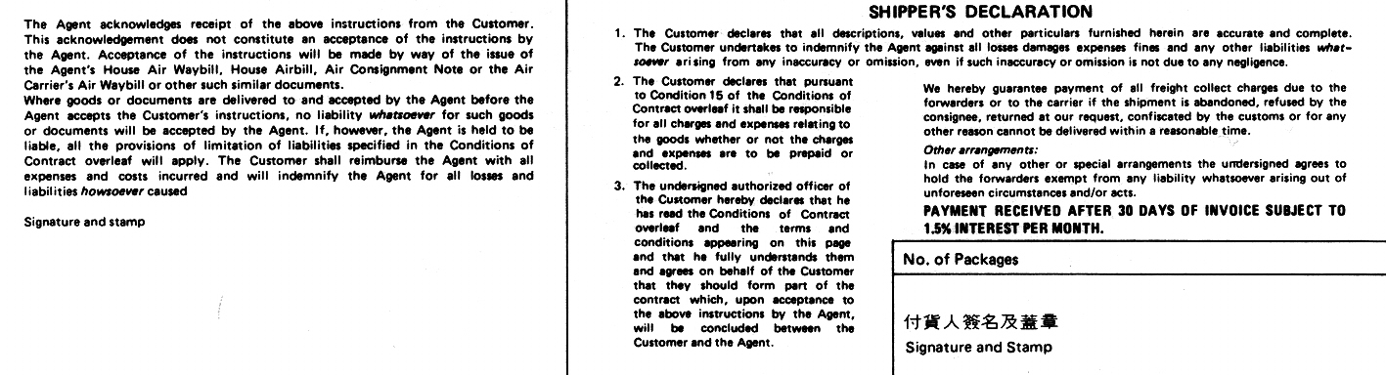
Date (MM/DD/YY): |  |  |  |  |  |  | Date (MM/DD/YY):
*Delete as appropriate
